**TITLE**

**Prediction of Intraoperative Acquired Pressure Injury in Elderly Cardiac Surgery Patients Using Machine Learning: Model Development with MIMIC-IV and External Validation**

**List of authors:**

Yi Cheng1#, Leqi Li1#, Jiang Zhang2#, Jifang Zhou3, Lihai Chen 2, Hongwei Shi2, Wang Yun2*, He Wei2*, Fan Yang1*

1 School of Science, China Pharmaceutical University, Nanjing, China

2 Department of Anesthesiology, Perioperative and Pain Medicine, Nanjing First Hospital, Nanjing Medical University, Nanjing, China

3 School of International Pharmaceutical Business, China Pharmaceutical University, Nanjing, China.

#These authors contribute equally to this study.

*Corresponding Author

Address correspondence to:

Fan Yang, School of Science, China Pharmaceutical University, Nanjing, Jiangsu, China. E-mail: yf@cpu.edu.cn; Phone: 02586185121; Fax: 02586185121.

**List of Figures**

**Figure S1.** Feature selection flowchart.

**Figure S2**. Correlation check results of the feature subset.

**Figure S3.** SHAP Analysis.

**Fig S4.** LASSO regression nomogram.

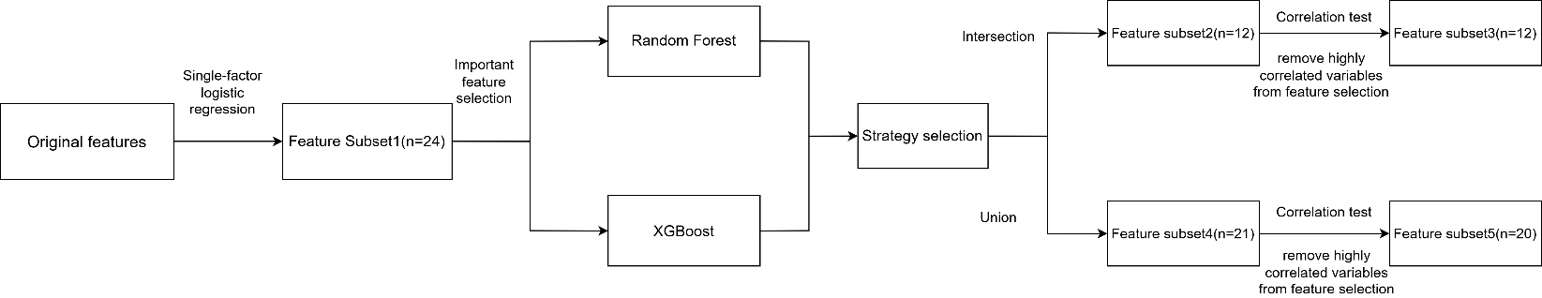

**Figure S1.** Feature selection flowchart.

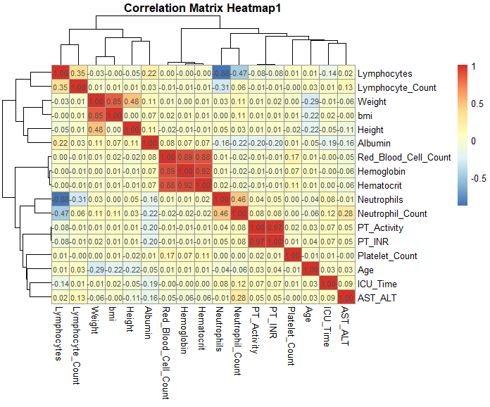

**Figure S2.** Correlation check results of the feature subset.

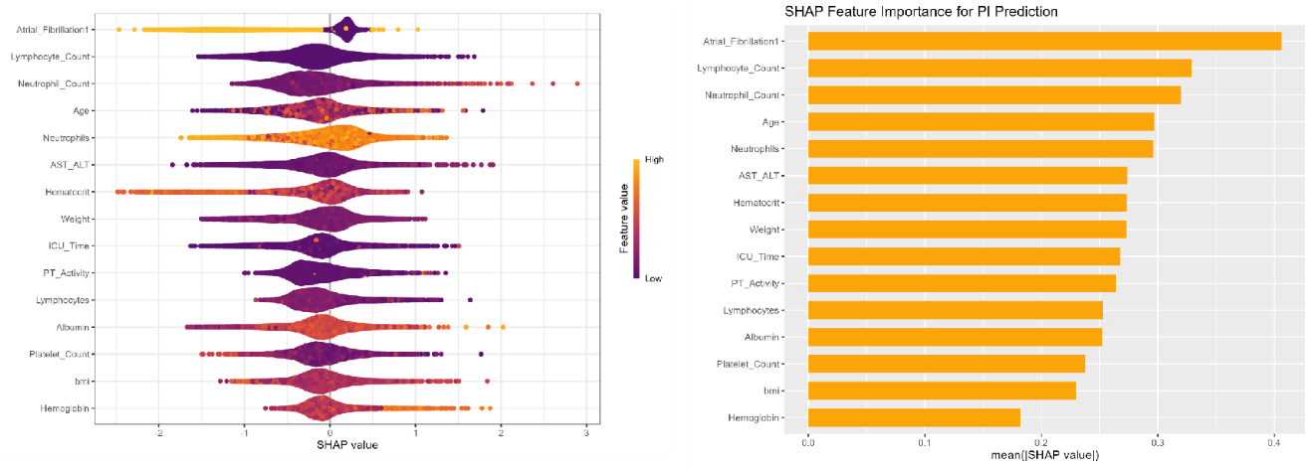

**Figure S3.** SHAP Analysis.

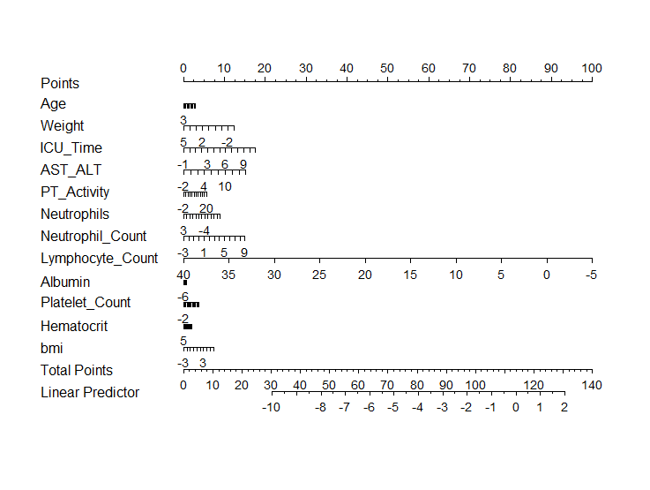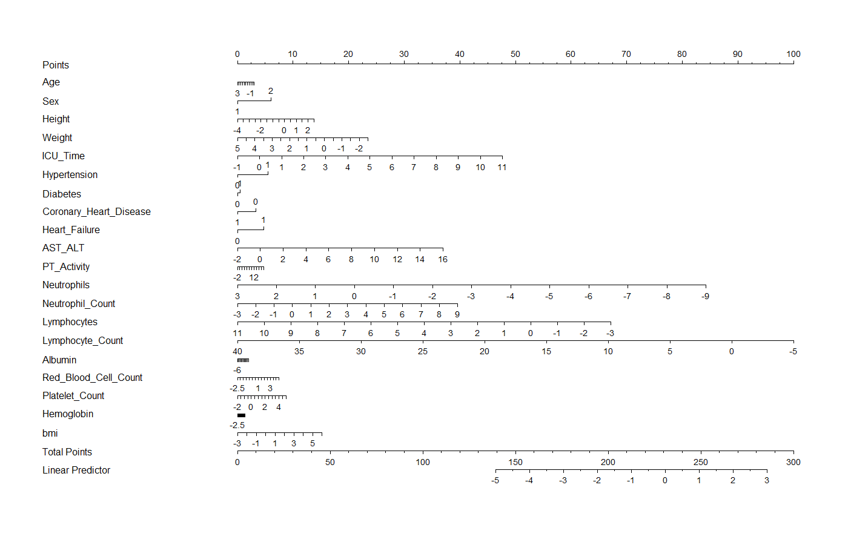

A

B

**Fig S4.** LASSO regression nomogram. (a) Feature intersection. (b) Feature union.